Day 1 | - 10:00-11:30 am : Lecture 1- Implant systems and classification,  - 11:30am -12:00 pm : Tea Break  - 12:00 -1:30 pm: Lecture 2 - Biomaterials for Implants, Implantology Armamentarium  - 1:30 -2:30 pm: Lunch break  - 2:30- 4:30 pm : Lecture 3 – Scientific Rationale for Dental Implant Design
Day 2 | - 10:00-11:30am: Lecture 4 – Bone Physiology . Bone quality and quantity, Osseointegration.  - 11:30am- 12:00 pm : Tea break  - 12:00-1:30 pm : Lecture 5 – Diagnostic Casts and Surgical Templates  - 1:30- 2:30 pm : Lunch Break  - 2:30-4:30 pm : Lecture 6 – Completely Edentulous Mandible
Day 3 | - 10:00-11:30 am : Lecture 7- Maxillary Arch Implant considerations  - 11:30am- 12:00 pm : Tea break  - 12:00- 1:30 pm :Lecture 8- Single Tooth Implant Replacement  - 1:30- 2:30 pm : Lunch Break  - 2:30- 4:30 pm : Lecture 9- Implant Maintenance and Failure
Day 4 | Recreation – Trek to Murari Temple / Lake Parashar/ Lake Riwalsar/ Camping at Tirthan Valley/ Kasol / Koldam
Day 5 | HANDS ON
Day 6 | HANDS ON
Day 7 | Recreation – Excursion to the Holy city of Mandi / Lake Prashar/ Lake Riwalsar / Camping at Tirthan Valley / Kasol/ Koldam
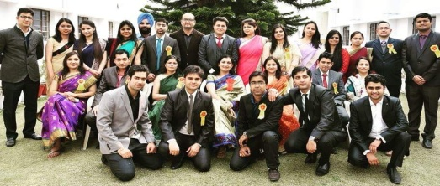
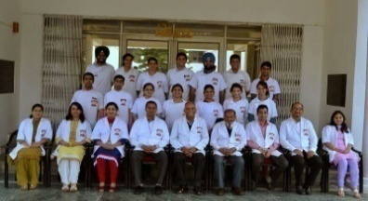
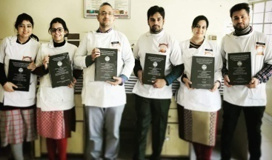
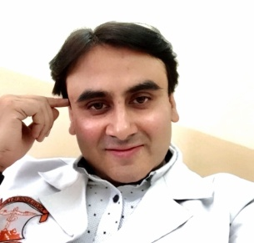
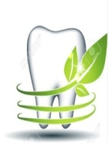
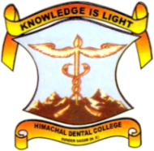
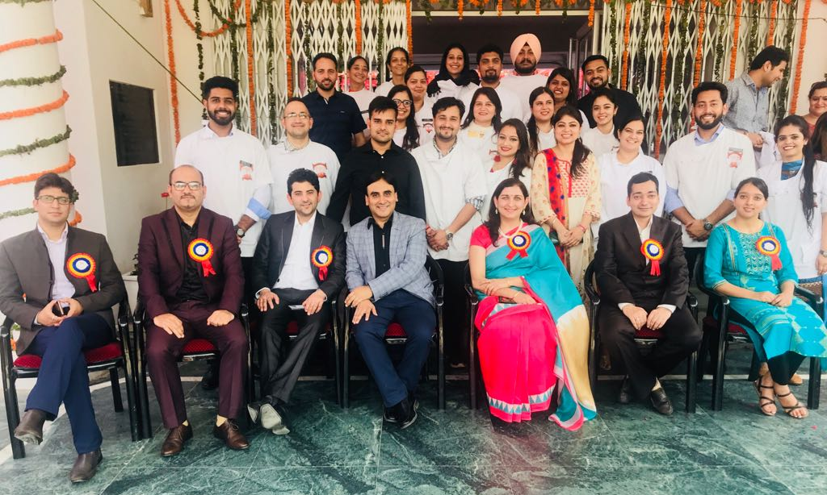
Dr. Rajeev Gupta
Professor

TOPIC : IMPLANTOLOGY OVERVIEW
Dr. Archana Nagpal
Professor & H.O.D

DEPARTMENT OF PROSTHODONTICS AND CROWN & BRIDGE
INTERNATIONAL STUDENT EXCHANGE PROGRAM – 2018
MODULE 3 (7 DAYS)

